NAAN MUDALVAN ASSIGNMENT

NAME: JAYASRI S

DEPARTMENT: BE ELECTRICAL AND ELECTRONICS ENGINEERING

COLLEGE: 8110 IMAYAM COLLEGE OF ENGINEERING

NAANMUDALVAN COURSE: DIGITAL MARKETING

NM ID: B75BB64AEB73255A4F74689EBCF7F95D

ASSIGNMENT 1:

Create a blog or website using blogspot and word press. Customize the them design and post new article with 500 words.

URL: <https://laranarestaurants83.blogspot.com/2023/10/larana-restaurants-fine-dining.html>

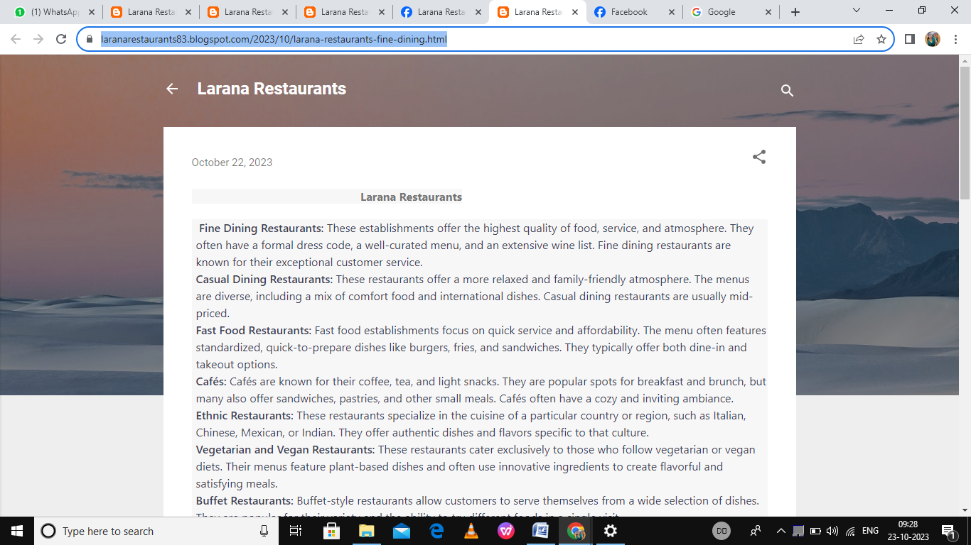

ASSIGNMENT 2:

Create a new Facebook business page and post one social media poster for your brand.

### .

<URL:https://www.facebook.com/larana.restaurants.2023?mibextid=ZbWKwL>

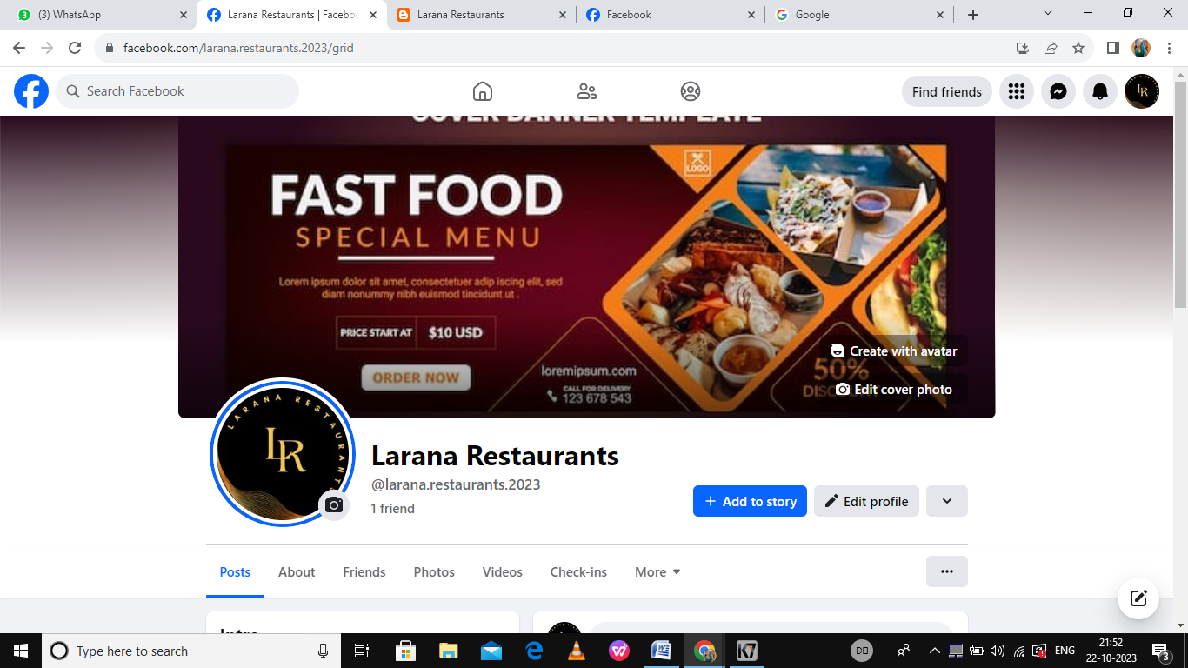

ASSIGNMENT 3:

Create and design a advertisement poster using canva.

URL: <https://laranarestaurants83.blogspot.com/2023/10/blog-post_22.html>

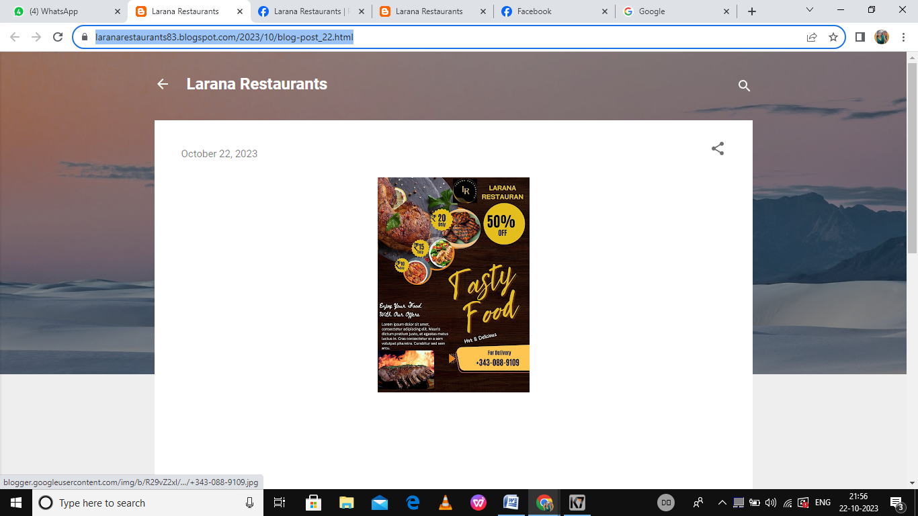

ASSIGNMENT 4:

Create an E mail newsletter design using mailchimp or canva tool.

URL: <https://laranarestaurants83.blogspot.com/2023/10/blog-post.html>

